**DAILY ONLINE ACTIVITIES SUMMARY**

|  |  |  |  |  |  |  |  |
| --- | --- | --- | --- | --- | --- | --- | --- |
| **Date:** | 16-06-2020 | | | | **Name:** | Amrutha G | |
| **Sem & Sec** | Fourth sem section A | | | | **USN:** | 4AL18CS006 | |
| **Online Test Summary** | | | | | | | |
| **Subject** | | Complex analysis, probability and statistical methods | | | | | |
| **Max. Marks** | | 30 | | **Score** | | 24 | |
| **Certification Course Summary** | | | | | | | |
| **Course** | **Introduction to information security** | | | | | | |
| **Certificate Provider** | | | greatlearning | **Duration** | | | 6 hr |
| **Coding Challenges** | | | | | | | |
| **Problem Statement:**  1: program to binary reversal of a number. | | | | | | | |
| **Status:** completed | | | | | | | |
| **Uploaded the report in Github** | | | | yes | | | |
| **If yes Repository name** | | | | https://github.com/AMRUTHAGANESH/lockdown-codings | | | |
| **Uploaded the report in slack** | | | | yes | | | |

**Online Test Details:**

The test for today was from module 1. The test was of objective type questions and there were 30 questions and the duration was 45 minutes. The questions were optimal and easy. The score that I got was 24/30.

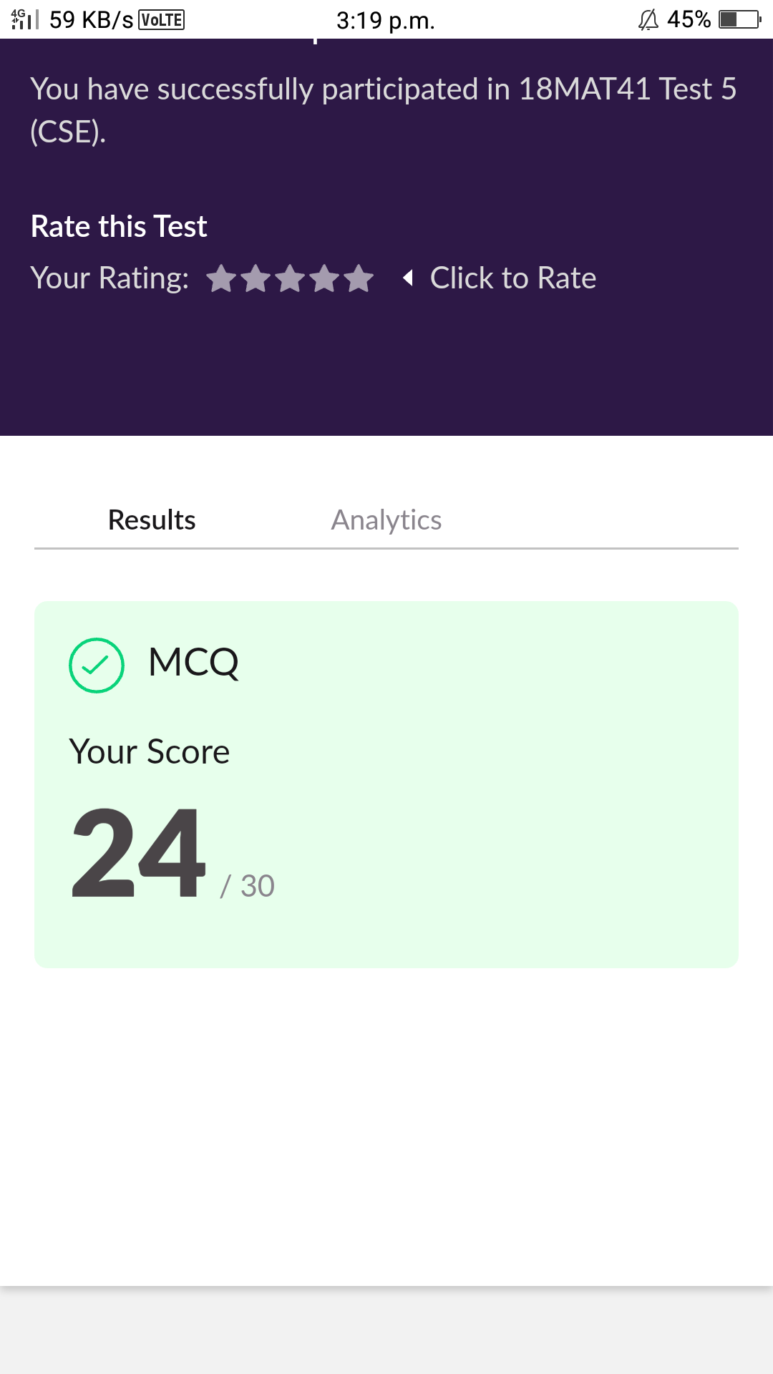

**Online Course Details:**

1. Name of course: **Mastering big data analytics**

Certificate provider: greatlearning

In today's sessions I learnt computer security it's application and it's feature innovations in cyber security and quantum security and also learnt what is the future of cryptography

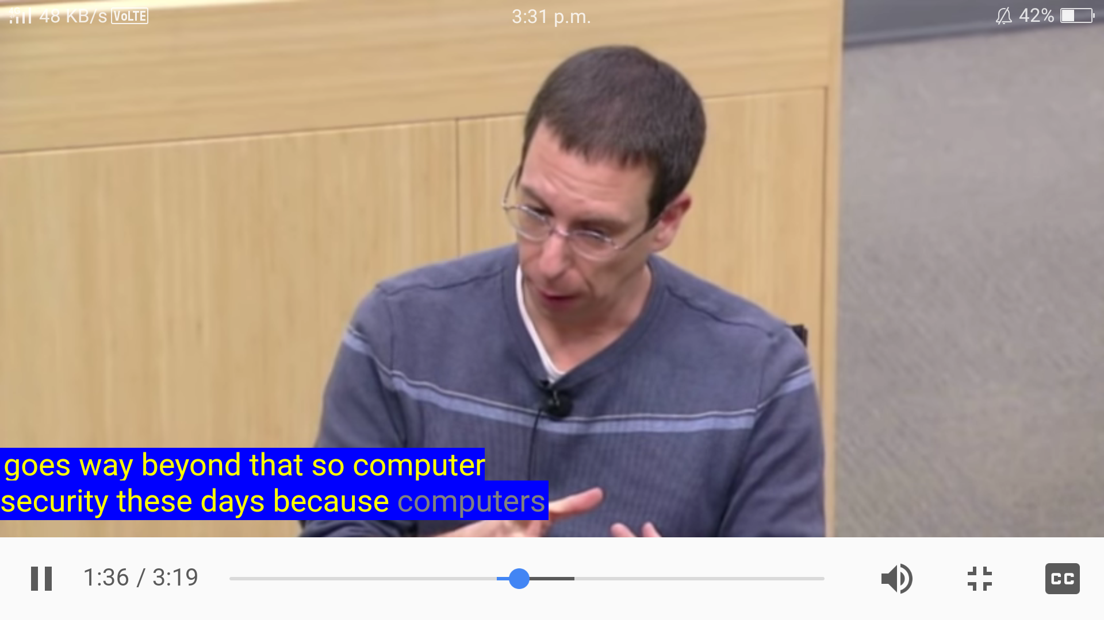

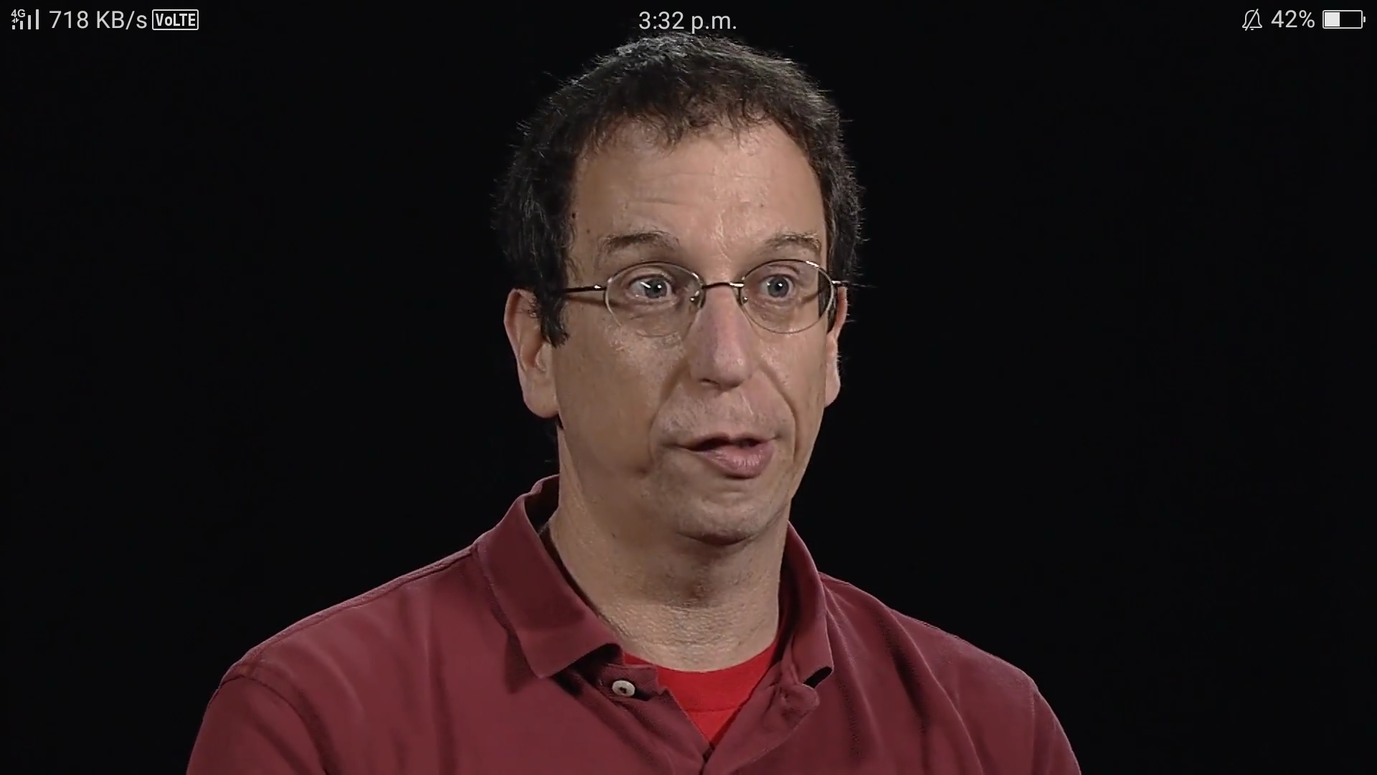

**Online coding:**

Problem 1: (using C language) program to binary reversal of a number.

